Name: ___________________________________ Date: ___________ Hour: ______ 10 B
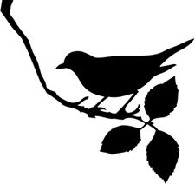
To Kill a Mockingbird
Introduction Notes

Directions: Record the important information for each of the topics below. Remember, you do not need every single word on a slide and you can summarize or paraphrase the main ideas.

Harper Lee Biography Notes | To Kill a Mockingbird Notes
 | 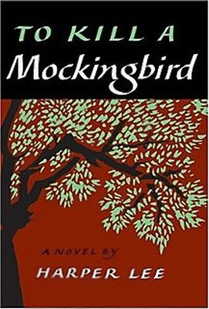

Characters
Atticus Finch | Jem Finch | Scout Finch | Dill Harris | Calpurnia
Boo Radley | Miss Maudie | Tom Robinson | Mayella Ewell | Bob Ewell

Title
What do you think the title To Kill a Mockingbird could mean?
________________________________________________________________________________________________________________________________________________________________________________________________________________________________________________________________________________________________________________________________________________________________________________________________________________________________________________________________________________________________________________________________________________________________________

